Asteroid Impact Model
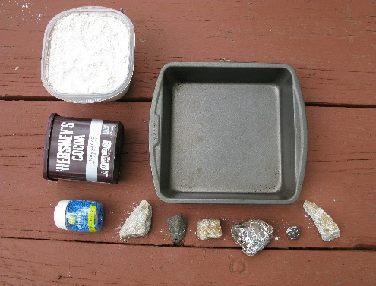
The face of the moon is covered with impact craters left behind by asteroids that have struck the moon throughout its existence. Lunar dust is a fine mineral powder that moves easily when an asteroid crashes into the moon.
You Will Need:
- A pan of any size, the bigger the better (foil pans are recommended)
- Flour
- Sprinkles and cocoa powder (optional)
- Hard objects like rocks, washers, bolts, etc. of various sizes

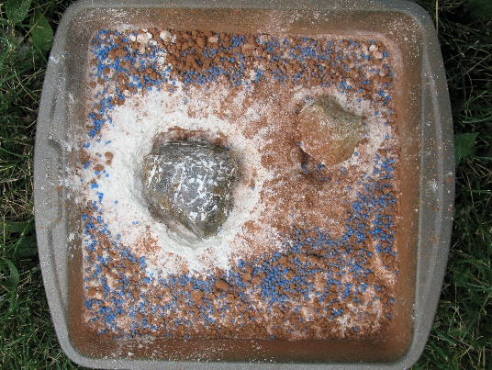
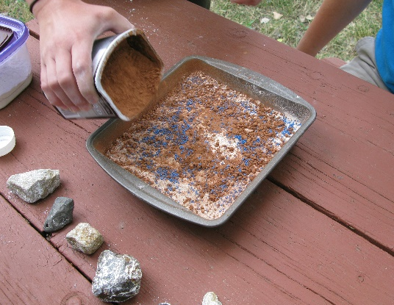
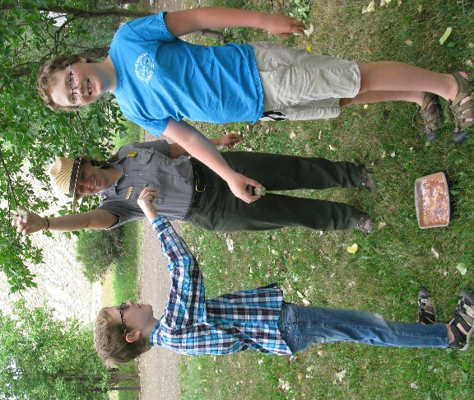

What to Do:
- Fill the foil pan with a thick layer of flour to represent the dust on the surface of the moon
- Cover the flour with a layer of sprinkles and a third layer of cocoa powder (optional step)
- Drop heavy items onto the surface of the ‘moon’ and look at the impact craters the heavy objects leave behind. Try throwing the objects from different heights and angles.

This is a great model to look at the impact craters left behind by an asteroid. Models like this can help us to visualize how the craters on the moon were also formed.

